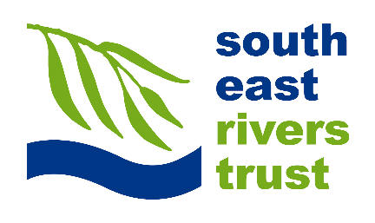

Application Form
Project Officer
Please complete this form and email it with a copy of your CV (2 pages max) by Monday 4th November to jobs@southeastriverstrust.org.

Your interest in this position
Please outline why you are applying for the position of Project Officer with SERT. What attracts you to the role and why do you think you are well suited to it?
Please enter your response here...

Rivers and the Environment
Please briefly answer the questions below:
What’s your favourite river and why?

What is it that makes you want to work in the environmental sector?
What do you see as being the most challenging issue that faces the rivers in the South East of England? Please explain your reason for choosing it.

Your river restoration skills and experience
Please give a brief summary of your experience and any particular skills in the following areas, with examples where appropriate:
What areas of river restoration particularly interest you and why? (e.g. fish passage, habitat improvements, wetlands etc.)
What types of river restoration projects have you worked on?
What river restoration project that you have worked on stands out the most in your mind (for good or bad reasons) and why?

In the project above, what was your role and what did you bring to the outcome?
If you were limited to only use one technique to enhance rivers, what would your favoured approach be?

Please explain how you have led on or fed into the design process of a restoration schemes?
Please outline what experience you have of managing projects and/or budgets? (if you do not have any, please don’t worry about answering this question).

About you
Please briefly answer the questions below:
What do you enjoy most in a job?

What do you consider will be the main strength that you will bring to the Trust?
If you were offered the position when could you start?

Anything else
Please use this space to tell us anything else you would like to
Please enter your response here...

